**Dataset Descibtion :**

The dataset is consist of 7 elements named as soil moisture at 15 cm, 45cm and 80 cms, Temperature, Humidity, Pressure and Luminosity. The Time stamp of the dataset is recorded in the format of the epoch time, which is called as the Unix time, this time format is in seconds and is globally used by the researchers and the developers. The soil moisture is measured in the m/m3, Temperature in the *C, Humidity in the percentage of the water in the air. The Pascal unit is used to measure the pressure and the Luxs is used to measure the Lumosity of the environment. A schema of the above dataset is depicted in the below Table 1.

|  |  |  |  |  |  |  |  |
| --- | --- | --- | --- | --- | --- | --- | --- |
| **date_time** | **S_M_15cm** | **S_M_45cm** | **S_M_80cm** | **Temperature** | **Humidity** | **Pressure** | **Luxes** |
| 11/22/2011 1:00 | 2380.95 | 3649.63 | 1396.64 | 24.2 | 66.76 | 98640.6 | 1406 |
| 11/22/2011 2:00 | 2380.95 | 3649.63 | 1396.64 | 24.26 | 67.41 | 98638.98 | 1404 |
| 11/22/2011 3:00 | 2380.95 | 3649.63 | 1396.64 | 24.28 | 66.26 | 98633.82 | 1408 |
| 11/22/2011 4:00 | 2380.95 | 3649.63 | 1392.75 | 24.32 | 66.79 | 98630.31 | 1416 |
| 11/22/2011 5:00 | 2380.95 | 3649.63 | 1392.75 | 24.37 | 65.76 | 98634.68 | 1421 |

An ARIMA is an univariate model based on the time series analysis, the model is working with the .three parameters Auto-Regressive, Integration and the Moving Average. In the Auto-Regressive it is the autocorrelation of the more than two observations. The integration is the step by step visualization of the data based on the time series. It has degree as a unit which shows the differencing order of the data, the differencing order of the 1 means one step ahead, the differencing 2 means two step ahead. A similar example of the differencing is given below in Table 2. The differcing order of the dataset led to removed the seasonality from the dataset.

Table 2: Understanding order of the differcing

|  |  |  |
| --- | --- | --- |
| **DataSet** | **Order 1** | **Order 2** |
| t1 |  |  |
| t2 | t1 |  |
| t3 | t2 | t1 |
| t4 | t3 | t2 |
| t5 | t4 | t3 |
|  | t5 | t4 |
|  |  | t5 |

In the Table 2, t, t2 and so-on are the observations recorded at the particular time interval. The order 1 in Table 2 depicts the next step ahead observation and similary the next two ahead step are computed in the differcing order 2.

Moving Average is the mean average of the dataset with a windows width of the *n* elements, where *n* can be anything like 1,10, 100.

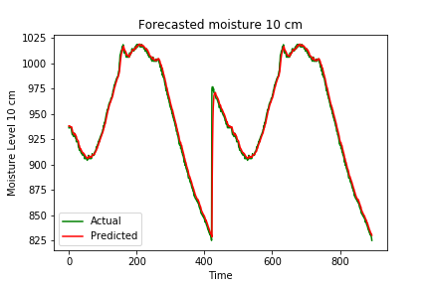

Table 3. Error rate of the Soil Moisture at 15 cms

|  |  |
| --- | --- |
| **Error** | **Value** |
| MSE | 47.3 |
| MAE | 2.94 |
| RMSE | 6.83 |

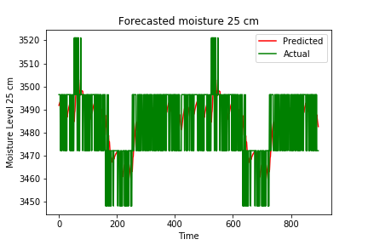

Table 4. Error rate of the Soil Moisture at 45 cms

|  |  |
| --- | --- |
| **Error** | **Value** |
| MSE | 179.25 |
| MAE | 13.38 |
| RMSE | 11.52 |

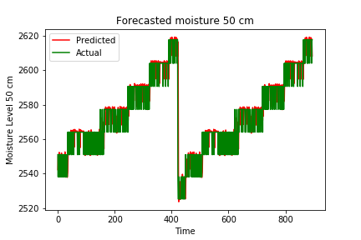

Table 5. Error rate of the Soil Moisture at 80 cms

|  |  |
| --- | --- |
| **Error** | **Value** |
| MSE | 80 |
| MAE | 6.12 |
| RMSE | 8.9 |

**Temperature**

It is the basic parameter of the environment, consists the value of the temperature of our surrounding where these value collects the value of the heatness from the environment, greater the heatness shows higher the value and lower the heatness depicts the cooled environment which has the lower value which may be range in the values of the minus. Scientifically the temperature are recorded in the three different scale such as Farnheit, Celcius and the Kelvin. In this dataset the Celcius based scale is used to record the heatness of the environment and the unit is *C.

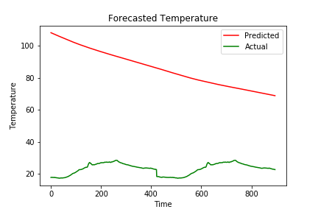

Figure 4: Temperature

The recordings of the temperature are recorded from the first day, initially it was 24*C and and remains same as an average of the whole dataset. The original temperature is in the green color and the forecasted observations are red in color. The forecasted observations are starts from the value of the more than 100*C, which is the far more as the expected observations. In the whole scenario the forecasted temperature has huge error rate, which describe the model is not adequate and has worst performance. The red line starts from 100*C + temperature and it declining to the next observations till the last reading. The error rate of the Temperature is depicted in the Table 6.

Table 6. Error rate of the Temperature

|  |  |
| --- | --- |
| **Error** | **Value** |
| MSE | 4082.34 |
| MAE | 62.62 |
| RMSE | 63.90 |

**Humidity**

The Humidity is the quantity of the water particles in the air, the numerous amount of the tiny water particles are present in the air and these water particles or the water vapour plays an important role in the today’s life. The more amount of the humidity leads to the suffocation or the high humid environment specially in the case of the cloudy weather alternatively the low amount of the humidity leads to the dry environment. The humidity is measure in the percentage, the amount of the water presence in the environment divided by the amount of the dry air in a certain air at a particular place. The higher the value like 100% means the most of the air is Saturated with the water particles and minimum the value such as 0% means the less air is saturated with the water. The hilly areas has the humidity upto 100 and the plain area like Patiala has humidity value to the 0 percent.

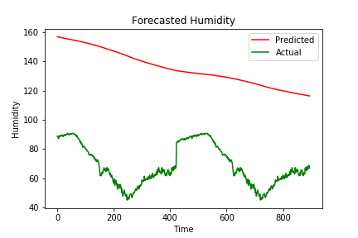

Figure 5: Humidity

The humidity of the dataset is recorded in the percentage. The minimum value of the humidity is 45% and the maximum is 81% in the whole observations. During the day time the humidity remains low in the terms of values and the in night time it has high values. The actual values are shown in green co

Table 7. Error rate of the Humidity

|  |  |
| --- | --- |
| **Error** | **Value** |
| MSE | 4665.12 |
| MAE | 66.6 |
| RMSE | 68 |

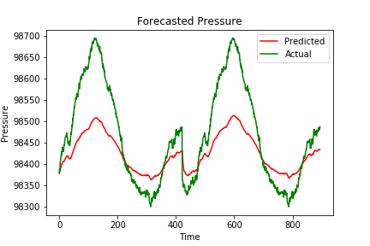

Table 7. Error rate of the Pressure

|  |  |
| --- | --- |
| **Error** | **Value** |
| MSE | 6989. |
| MAE | 65.96 |
| RMSE | 83.60 |

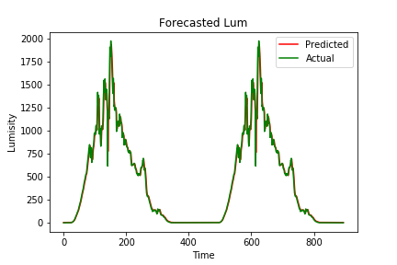

Table 7. Error rate of the Luminosity

|  |  |
| --- | --- |
| **Error** | **Value** |
| MSE | 4002 |
| MAE | 28.5 |
| RMSE | 63.26 |